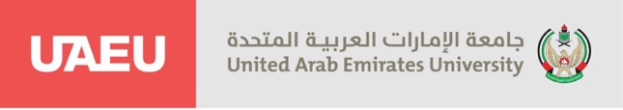
Department of Mass Communication
Internship Fall 2025
Practicum (51)
Submitted to Professor Badreya Al-Jenaibi

Internship weekly report
Student name: Sarah ali almesmari Student ID: 202104639
Training organization: Fujairah police at UAEU Week:11
Field Supervisor: Salma Albalghouni
Academic supervisor: prof. Badreya Aljenaibi

During the eleventh week of my training at the Fujairah Police General Headquarters, I participated in the Flag Day celebration. The event was organized by the General Headquarters of Fujairah Police as part of the UAE’s national initiative launched by His Highness Sheikh Mohammed bin Rashid Al Maktoum.
The celebration took place at the headquarters with the presence of Directors General, department heads, officers, staff, and female personnel. Brigadier General Mohammed bin Naye’ Al-Teneiji, Deputy Commander General of Fujairah Police, raised the national flag amidst a patriotic atmosphere. Students from various schools in Fujairah also participated with performances expressing their pride and love for the UAE flag.
I co-wrote the news report about the celebration with Professor Salma, highlighting the significance of the flag as a symbol of national identity, unity, and loyalty to the leadership. This task helped me apply my skills in journalistic writing and reporting on official events.

